The use of alumina-chrome refractories in the high wear areas of anode refining vessels
Last name, First Name, Company or University, Country
Last name, First Name, Company or University, Country
Last name, First Name, Company or University, Country
Last name, First Name, Company or University, Country
Abstract
Refractory lining designs based on products containing direct-bonded or rebounded fused grain magnesia-chrome have been the industry-wide standard for anode refining vessels in all primary copper smelters. These linings are usually zoned with the denser rebounded fused grain material at the severe wear areas at the tuyeres, taphole, skimming ports and charging mouth. This zoning aids to improve the lining performance in these areas but commonly the vessels must be taken out of service every 4-6 months for maintenance. It has been shown in the past that wear mechanisms leading to severe joint penetration at the skimming ports and significant spalling of the brick in the tuyere areas are a result of copper oxide penetration and reaction.
1 Introduction
Include Purpose (Objectives) and Scope in the Introduction. Over the past several decades, there has been a determined attempt to optimize the microstructural, chemical, and fracture properties of the magnesia-chrome refractories used in non-ferrous pyrometallurgical vessels. Furthermore, lining design concepts involving larger and longer brick and the extent and positioning of expansion allowance have been extensively trialed. Some benefits have been achieved by increasing the heat flux through the lining by removing any insulation at the sell/working lining interface.
2 Refractory Quality
Molten copper has little if no affinity for refractory oxide furnace linings (Fig. 1). Channel induction furnaces used to melt cathode copper are lined with inexpensive fireclay products and operate continuously without repair for up to four years. However, these furnaces utilize a layer of charcoal or low sulphur coke to eliminate any possibility of forming copper oxide slag by contact of the molten bath with oxygen in the atmosphere.

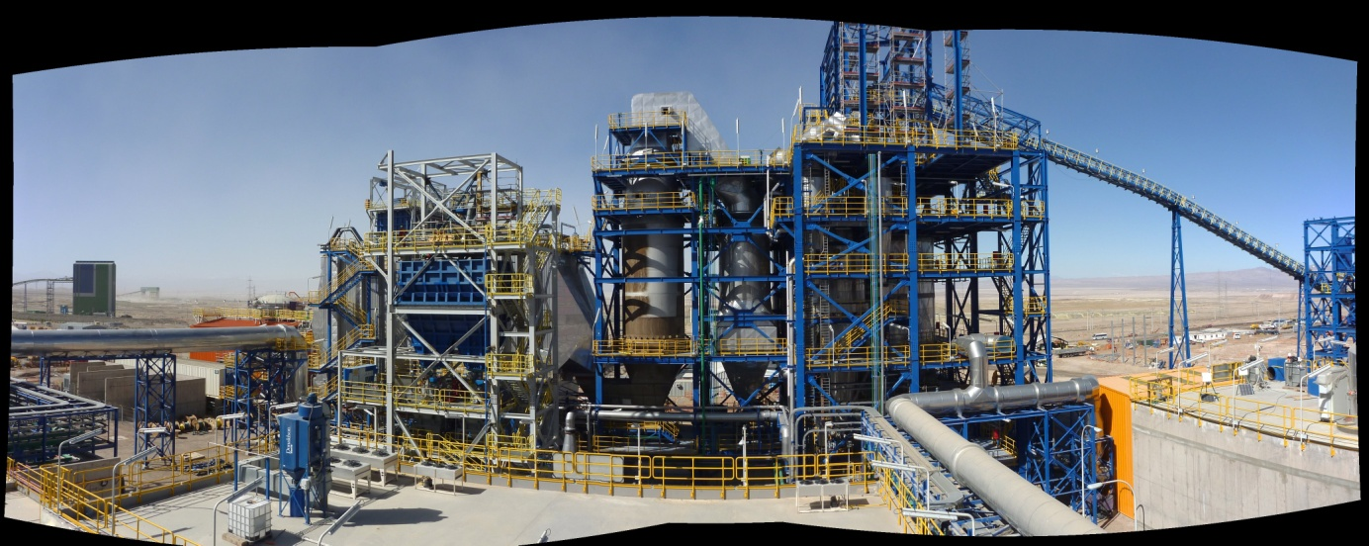
Figure 1 Roasting plant at MMH, looking south. Picture taken July 2013
3 Lining Design Concepts
A well-engineered design for an anode vessel will effectively zone the high wear areas with suitably resistant products and ensure the lining is in excellent thermal contact with the vessel steel shell. Maximizing the thermal contact aids in producing a steep thermal profile, which minimizes penetration of slag into the hot face of the lining, subsequently reducing the corrosion rate of the brick. In some cases, a graphite-containing mastic should be employed to safeguard against air gaps between the cold face of the brick and the steel shell.
3.1 Anode Vessel Lining Design History
The original concept of using chromic oxide containing refractories was developed in a copper smelter that was using siliceous slags to remove contaminating lead values from the anode copper. The skimming lip of the anode vessel mouth was normally lined with rebounded fused magnesia-chrome bricks installed in place with a standard magnesia-chrome mortar (Fig. 2).

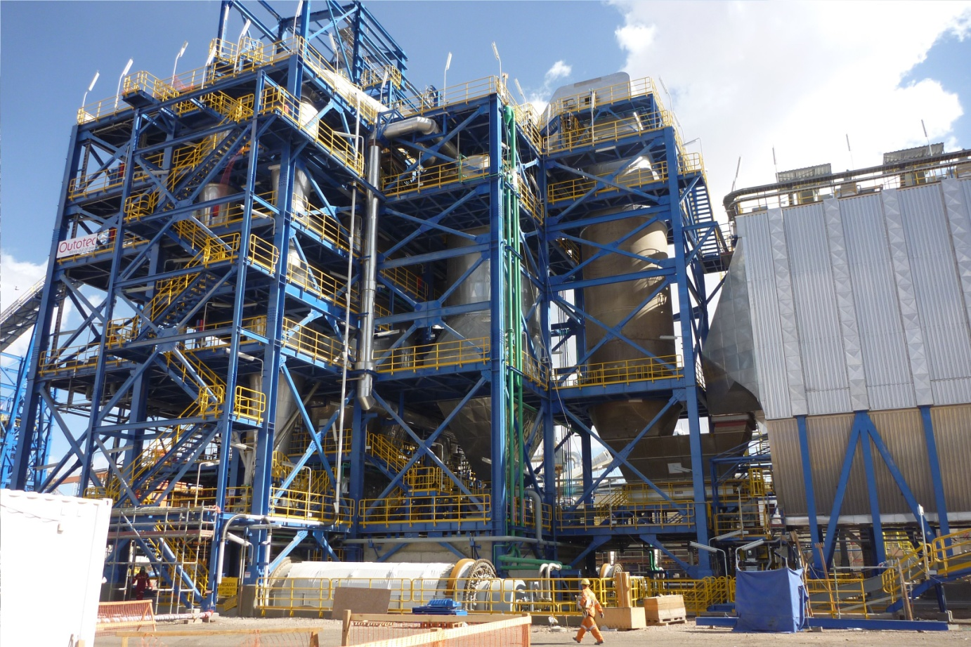

Fig. 2 Skimming lip of an anode mouth lined with rebounded magnesia-chrome bricks placed with a phosphate-bonded alumina-chrome mortar
At the same time that the field trials were being conducted alumina-chrome Monolithics and fired brick samples were tested with copper oxide in the laboratory. The copper oxide was placed in slag cup samples at temperatures of 1400°C which is far in excess of the typical working temperatures (Table 1)

Table 1 Separation efficiencies of APU at Amarillo Copper Refinery
Streams | H₂SO₄ (g/L) | Ni  (g/L) | Cu (g/L) | As (g/L) | Fe (g/L) | Bi (mg/L)
APU Feed:  Decopperized Electrolyte | 255.4 | 7.3 | 1.04 | 3.09 | 0.96 | 158
APU Product | 219.7 | 2.4 | 0.35 | 2.64 | 0.38 | 65.8
APU Byproduct | 35.7 | 4.9 | 0.69 | 0.45 | 0.58 | 92.2
Loss / Removal | 14.0% | 67.2% | 69.0% | 14.4% | 60.5% | 58.3%
Table 2 Comparison between predicted and actual sodium carbonate consumption.
 | Sodium Carbonate
Volume  (Liters) | Predicted  (grams) | Actual  (grams) | Ratio  (predicted/actual)
3 | 594.0 | 615.3 | 0.965
3 | 295.1 | 321.8 | 0.917
6 | 500.9 | 515.7 | 0.971
6 | 282.0 | 296.5 | 0.951

Table 3 The reinforcement of electrolysis in No.1 and No.2 tankhouses
 | Original | Modified
Amperage per cell, kA | 20 | 23
Current density, A/m² | 222 | 250
Anodes weight, kg | 365 | 380
Anodes per cell, pcs | 46 | 46
Cathodes per cell, pcs | 45 | 45
Cathode production , m-T/M | 10,900 | 12,400

Table 4 Outgoing concentration of antimony in the electrolyte for each resin bed column analyzed.
Resin | MX-2 | UR-3300S | Duolite C-467
t [h] | Sb [kg/m3] | Sb [kg/m3] | Sb [kg/m3]
1 | 0.0296 | 0.0366 | 0.0398
2 | 0.1025 | 0.0544 | 0.1085
3 | 0.1071 | 0.0615 | 0.1170
4 | 0.1095 | 0.0616 | 0.1139
5 | 0.1195 | 0.0605 | 0.1175
6 | 0.1198 | 0.0611 | 0.1186
7 | 0.1201 | 0.0617 | 0.1191
8 | 0.1201 | 0.0619 | 0.1189
1 Hydroxides: Most common precipitation method, typically follows the reaction
$$M^{+n}+n{OH}^{-}\overset{⇔}{}M{\left(OH\right)}_{n}$$
2 The selection of the phases is dependent upon the generation of oxygen from the electrolytic decomposition of water, equation 1.
2H₂O O₂ + 4 H⁺ + 4 e E_{(O2/H2O)} = 1.229 – (.059/4) [4 pH – log (p_{O2})]

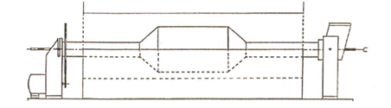
Figure 1 Rotary tube furnace with sample holder
3.2 Alumina-Chrome Filed Trials
The skimming mouth trials and the results of the laboratory work elucidated the considerable corrosion and penetration resistance of chromic oxide to copper oxide slag. A design was therefore drawn up to develop an anode vessel lining in which all the high wear areas were all zoned with a brick lining to the shell with both alumina chrome brick and precast monolithic tuyere blocks.
4 Results
Summarize the main technical, economical, and other results of your paper.
5 Conclusions
It is certainly quite apparent that any improvement to the overall refractory life of an anode refining vessel requires zoning of the most severe localized wear areas with particularly corrosion resistant materials.
6 Recomendations
It is certainly quite apparent that any improvement to the overall refractory life of an anode refining vessel requires zoning of the most severe localized wear areas with particularly corrosion resistant materials.
Acknowledgement
The authors would like to thank PT. from China for allowing the publication of this Paper. We would like also to acknowledgment all those involved.

References
A.J. Rigby. “Controlling the Processing Parameters affecting the Refractory Requirements for Peirce-Smith Conveters and Anode Refining Vessels”

Iain B. Mackenzie, O. Pasca, A. Enriques and A.J. Rigby. “Use of Microporous Insulation in Copper Holding Furnaces at BHP San Manual Smelter” Copper 99-Vol.V. Smelting Operations and Advances. Phoenix, Arizona, U.S. 457-464.

